**24-25 January 2013**

**University of Southampton**

**Avenue campus**

**@elearnLLAS #elearnLLAS**

**E-learning Symposium 2013**

**8th edition**

**PROGRAMME**

**Supported by**

****



**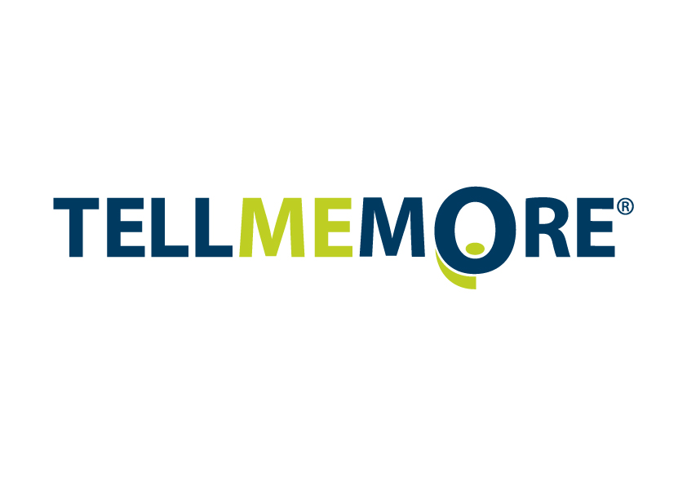******

Day 1 – Thursday 24 January 2013

|  |  |  |
| --- | --- | --- |
| 09.45-10.15 | Avenue café | Registration and tea / coffee |
| 10.15-10.30 | Lecture  Theatre A | Welcome and introduction to the day  **Professor Anne Curry, Dean of Faculty of Humanities, University of Southampton** |
| 10.30-11.15 | Lecture Theatre A | *Keynote address*  **Nik Peachey, Associate Trainer** [**Bell Educational Services**](http://www.bellenglish.com/BellGroup/Educationalservices/)  *Making e-learning social and collaborative* |
| 11.15-11.45 | Avenue café | Tea / coffee |
|  | North corridor | sponsors’ exhibition |

|  |  |  |  |
| --- | --- | --- | --- |
| 11.45-12.45 | Parallel sessions 1 | | |
| Workshop A | Session 1.1 | Session 1.2 | Session 1.3 |
| Room 1177 | Room 1173 | Lecture Theatre C | Room 1163 |
| **Fiona Harvey and Lisa Harris,** **University of Southampton**  Digital literacy: living and learning on the Web | **Ruth Trinder, Vienna University of Business and Economics**  Blended learning, Web 2.0 and learner beliefs – promises and realities of students’ use of technology for language learning | **Mirjam Hauck, Beaven T., Comas-Quinn A., Lewis T., de Los Arcos B., The Open University**  Of MOOCS and MOTS: new wine in an old bottle?  This talk will be followed by an informal discussion:  **MOOCS and MOOCishness** | **Jonas Langner, University of Bristol**  Online grammar course for students of German |
| **Fernando Rosell-Aguilar,**  **The Open University**  i-Tunes U as a tool for language learning: the learners’ perspective | **Nuria Lopez, Newcastle University**  Working together: using a wiki to create a Spanish class dictionary |

|  |  |  |
| --- | --- | --- |
| 12.45-13.45 | Avenue café | Lunch |
|  | Room 1177 | poster display |
|  | North corridor | sponsors’ exhibition |
| 13.45-14.15 | Room 2151 | Session 2  **Showcase and demonstration of projects**  OpenLIVES / EAP Toolkit / Language Box / LORO (Languages open Resources Online) / MexCo / IRIS / TESOL Electronic Village / Languages@Warwick /  Online grammar course for students of German |

|  |  |  |  |
| --- | --- | --- | --- |
| 14.15-15.15 | Parallel sessions 3 | | |
| Workshop B | Session 3.1 | Session 3.2 | Session 3.3 |
| Room 2099 | Room 1173 | Lecture Theatre C | Room 1163 |
| **Kirsten Sontgens, University of Southampton**  Blended learning for languages. How to successfully integrate technology into everyday teaching | **Marina Orsini-Jones, Lloyd E., Gazeley Z., Bescond G., Vass H., Vera B., Coventry University & Universidad National Autónoma de México**  Negotiating intercultural awareness online: reporting on the first phase of an international exchange project between undergraduate students in the UK and in Mexico (MexCo) | **Nathalie Thorne, Leeds Metropolitan University**  Teaching interpreting via distance learning –possible or impossible? | **Helene Pulker and Anna Calvi, The Open University**  The evaluation and re-use of Open Educational Resources: a case study |
| **Jean-Christophe Penet and Helen Lowther, Newcastle University**  Autonomous e-learning to improve careers awareness and employability in first-year (post A-level) language classes | **Kate Borthwick,**  **LLAS, University of Southampton**  Finding a Voice through Open Resources: FAVOR project | **Teresa MacKinnon, University of Warwick**   Exploring the collaborative potential of Web 2.0 |

|  |  |  |
| --- | --- | --- |
| 15.15-16.00 | Avenue café | Tea / coffee |
|  | North corridor | sponsors’ exhibition |
|  | Room 1177 | poster display |
| **Marta Becquet,**  **University of Glasgow** | | Moodle (r)evolution – developing VLE for teaching Polish as a foreign language |
| **Serpil Meri,**  **University of Southampton** | | Investigation on Turkish students’ readiness for learner autonomy: inside and outside class activities |
| **Aiden Yeh,**  **Wenzao Ursuline College, Taiwan** | | Assessing the effectiveness of informal online teacher |
| **Julie Watson,**  **University of Southampton** | | Archi21: evolving a CLIL approach for language learning by students of Architecture and Design using a 3D immersive world combined with other 2D technologies |

|  |  |  |
| --- | --- | --- |
| 16.00-16.45 | Lecture Theatre A | *Keynote address*  **Professor Mike Neary, Dean of Teaching and Learning, University of Lincoln**  *Student as producer: a revolution in higher education?* |
| 17.00 | Avenue café | RosettaStone_Edu-yellowDrinks reception sponsored by |
| 19.00 | Ceno’s | Conference dinner |

Day 2 – Friday 25 January 2013

|  |  |  |
| --- | --- | --- |
| 09.15-09.45 | Avenue café | Registration and tea / coffee |
| 09.45-10.00 | Lecture  Theatre A | Welcome and summary of ‘social wall’  **Vicky Wright, Director of Language Strategy, University of Southampton** |
| 10.00-10.45 | Lecture  Theatre A | *Keynote address*  **Allison Littlejohn, Professor of Learning Technology, Glasgow Caledonian University**  *Learning in the open: the evolution of open educational practice* |

|  |  |  |  |
| --- | --- | --- | --- |
| 10.50-11.50 | Parallel Sessions 4 | | |
| Workshop C | Session 4.1 | Session 4.2 | Session 4.3 |
| Room 2151 | Room 1173 | Lecture Theatre C | Room 1163 |
| **Caoimhín Ó Dónaill University of Ulster**  CLILSTORE: A free online multimedia authoring tool and hosting service for language teachers | **Richard Galletly Aston University**  ‘Worth the effort?' How students of Academic Writing classes respond to supplementary video resources | **Maria Garcia-Florenciano University of Leeds**  Interviews as opportunities for learners to engage in authentic language use and collaborative communicative tasks | **Edith Kreutner University of Bristol**  Movie making for grammar learning |
| **Mark Stimpfig,**  **ConnectED**  SANSSpace - the language lab in the cloud | **Edward Hoyle,**  **TELL ME MORE®**  Customised Solutions for Successful Online Language Training | **Robyn Woodrow, SketchEngine**  Discover how words behave with SketchEngine |

|  |  |  |
| --- | --- | --- |
| 11.50-12.15 | Avenue café | Tea / coffee |
|  | Room 1177 | poster display |
|  | North corridor | sponsors’ exhibition |

|  |  |  |
| --- | --- | --- |
| 12.15-13.15 | Parallel Sessions 5 | |
| Workshop D | Session 5.1 | Session 5.2 |
| Room 2151 | Room 1173 | Lecture Theatre C |
| **Alannah Fitzgerald, University of Oxford IT Services, TOETOE International project, University of Waikato Greenstone Open Source Digital Library Software Lab (NZ), FLAX project**  FLAX weaving with Oxford Open Educational Resources: open practices and resources for English Language Teaching | **Nicolas Pino James, University of Warwick**  Potential of asynchronous CMC in developing speaking proficiency | **Michael Thomas, University of Central Lancashire**  Augmented Reality in language education: using QR codes to engage international students |
| **Marion Sadoux, London Metropolitan University**  ‘*Adieu l’anxiété*?’ Can Computer Mediated Communication help learners with Foreign Language Anxiety | **Billy Brick and Tiziana Cervi-Wilson, Coventry University**  Breaking down the classroom walls: Augmented Reality and language learning |

|  |  |  |
| --- | --- | --- |
| 13.15-14.30 | Avenue café | Lunch |
|  | Room 1177 | poster display |
|  | North corridor | sponsors’ exhibition |

|  |  |  |
| --- | --- | --- |
| 14.30-15.30 | Parallel Sessions 6 | |
| Session 6.1 | Session 6.2 | Session 6.3 |
| Room 1173 | Lecture Theatre C | Room 1163 |
| **John Canning, LLAS, University of Southampton**  No open learning without open access: a portal for open access research into teaching modern languages | **Julie Watson,**  **University of Southampton**  Is the Social Wall the new discussion forum? An evaluation of the use of a Web 2.0 social wall by students on an online course | **Antonio Martinez-Arboleda, University of Leeds Miguel Arrebola,**  **University of Portsmouth**  Transformational teaching in the OpenLIVES project |
| **Emma Marsden,**  **University of York**  IRIS: a new online resource for doing research into second language learning and teaching | **Julien Hamilton-Hart Swansea University**  Autocues for language learning: linguistic immersion, employability, and a transferable end-product | **Lucy Hill Newcastle University**  Spanish for medical students: fostering collaborative learning in mixed-level groups |

|  |  |  |
| --- | --- | --- |
| 15.30-15.40 15.40-16.25 | Lecture Theatre A | Prize draw  *Keynote address*  **Gráinne Conole, Professor of Learning Innovation, University of Leicester**  Harnessing new media, pedagogical innovation and new approaches to design |

|  |  |  |
| --- | --- | --- |
| 16.25 | Lecture Theatre A | Closing remarks |